Name ___________________Scientific Processes - Tools and Measurements Quick Lab
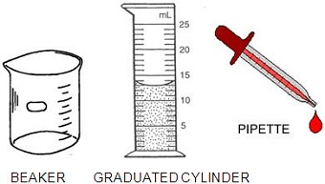
Materials needed: Pipette, graduated cylinder, ruler, meter stick, beaker, water, balance (scale), marbles, empty plastic food container, calculator

Part A – Count Your Drops
1. The image above shows various tools you will need.
What amount of liquid is in the graduated cylinder pictured?
(Measure at the lowest point of the curve.) ___
How much liquid can your graduated cylinder measure? _______
How much liquid can your beaker measure? _______
Look at the pipette – how many ml does the pipette hold? _____
2. Technique 1: Fill the pipette so that is shows that it is 1ml full. Slowly drip the water out of the pipette and count the drops. How many drops is in 1 ml of water.
3. Technique 2: Fill your graduated cylinder to 10 ml of water. Carefully add drops using the pipette until you reach 11 ml. Repeat this process 3 times in order to calculate an average.
Trial 1 | Trial 2 | Trial 3 | Average

Part B – The Volume of Solid Objects
1. Solid objects have a volume also (basically the amount of space the object takes up). Volume can be measured in two ways.
For symmetrical objects, volume is simply LENGTH x WIDTH x HEIGHT
Use a metric ruler to measure the box below and determine its volume (measure in cm)
The volume of the box is: ________________
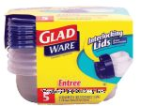
2. You can also determine the volume of a box-shaped container (like plastic food storage containers) using the same method. Measure the storage container’s length, width and depth.
Length = ____________ Width = ___________ Depth = __________
Calculate the volume of the container L x W x H (depth) = ______________
Flip the container over, it should have a label that says how much it will hold. What does it say? ____
Fill your container with water (you should be able to still fit the lid on it) , then carefully pour the water out into a graduated cylinder or beaker. How much did your container really hold? __________
3. For oddly shaped objects, using a water displacement technique can determine the volume. Find the volume of 3 marbles by filling a graduated cylinder to 20 ml. Drop the marbles in and see how much the water rises – this is the volume of the marbles. Complete the table below.

A) Volume of Water before adding marbles | B) Volume of Water after adding marbles | Calculate (B minus A)  Volume of all 3 marbles
10 ml (starting volume)
Now determine the volume of a single marble by dividing your total (above) by 3. ___________
Try dropping a single marble into the graduated cylinder. What is its volume? ____________
Part C – Length of Objects
1. The three units of length you will be most familiar with are: millimeters, centimeters, and meters. Use a meter stick to determine: - How many mm in a cm _________ How man cm in a m ____________
2. Use a meter stick or ruler to fill out the table below. (Grayed boxes need not be completed)
 | In millimeters | In centimeters | In Meters
Height of lab table
Length of lab table
Width of door
Your height
Height of graduated cylinder
Lengthof pipette
Length of your shoe
3. Which measurement is the largest? Circle your answer for each pair
a) 14 mm or 1 cm d) 145 m or 145 km
b) 334 m or 1 km e) 3.4 cm or 30 mm
c) 1 m or 990 cm f) 2 m or 250 cm
4. Circle the BEST metric unit for each.
a.) The length of an eyelash [ mm cm m km ]
b) The height of a flagpole [ mm cm m km ]
c) The length of your arm [ mm cm m km ]
d) The distance between Chicago and St Louis [ mm cm m km ]

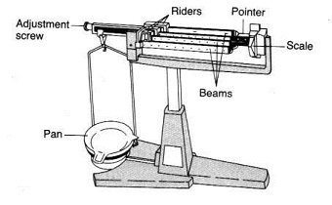
Part C: Mass of Objects
Tools: Electronic scale or balance.
1. Determine the mass (in grams) of the 3 marbles: _________
2. Determine the mass of 20 ml of water. To do this you will need to weigh an empty graduated cylinder , then add the water and find the difference.
Mass of Graduated cylinder ______
Graduated Cylinder + 20 ml of water ______
Mass of 20 ml of water _____
3. Use the same technique to determine the mass of 50 ml of water: ___________

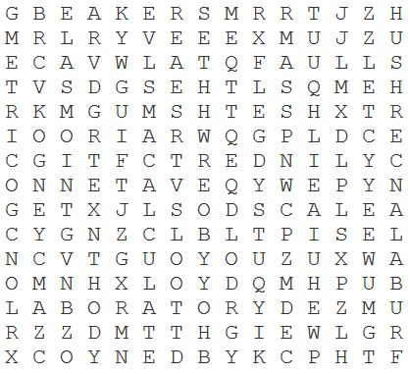
Scientific Tools Word Search:
BALANCE
BEAKER
CALCULATE
CENTIMETER
CYLINDER
GOGGLES
GRADUATED
LABORATORY
LENGTH
MASS
MEASURING
METRIC
PIPETTE
RULER
SAFETY
SCALE
TOOLS
VOLUME
WEIGHT
WIDTH

Questions to answer: (circle best answer)
1.Which weighs more? a. pound of gold b. pound of feathers c. neither
2. A tub holds 5000 liters of water. The tub is filled with 4000 liters of water. An object with a volume of 1100 liters, a mass of 60 kilograms, and a height of 120 cm is dropped into the tub. Will the water overflow?
a. yes b. no c. unknown
3. The length of your nose is best measured in: a. mm b. m c. ml
4. How many centimeters in a meter? a. 10 b. 100 c. 1000
5. How many milliliters in a liter? a. 10 b. 100 c. 1000
6. Which is a good estimate for the MASS of your textbook? a. 2 kg b. 100 kg c. 50 g
7. An average human is about how tall? a. 2 m b. 50 m c. 90 cm
8. What is a good estimate for the volume found in a soda can? a. 25 ml b. 50 ml c. 500ml
9. Which of the following tools measures volume? a. scale b. graduated cylinder c. ruler
10. Which of the following is the longest? a. 20 mm b. 20 cm c. 20 m

