Independent and Dependent (Responding) Variable Name________________Per_______
Scenario |  | Independent Variable | Responding Variable
1. One cow is fed a growth hormone and another cow is not. After a year, both cows are weighed. | 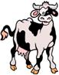
2. Mosquito repellent is sprayed on one arm and the other arm is not sprayed. The number of mosquito bites is counted after 2 hours. | 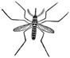
3. Bob studies for a test and Jackie does not study. After the test, they compare their scores.
4. Two cars are on a track and accelerate to 60 mph. At a certain point, both cars slam on the brakes. The distance it takes for each car to stop is then measured.
5. A group of people take a diet pill. After 3 months, they measure the amount of weight they lost.
6. Ants are placed in a tray that is shaped like a T, at the end of the T, the ants can either go to a darkened area or a light area. Students count how many ants end up on the dark side and how many end up on the light side. | 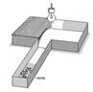
7. One company states that it makes the best staplers. To prove it, they use the stapler to staple a thousand papers and compare it to a competitor. The competitor’s stapler jammed 3 x whereas their stapler only jammed once.
8. A pediatrician designs baby formula to help babies gain weight. To show his formula works, he compares the weights of babies that have been using the formula to the weights of babies not on the formula. | 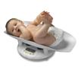
9. Cockroaches are exposed to the chemical dioxin. After 3 hours, 45/100 cockroaches are dead. | 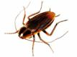
10. New houses are spayed on the outside with an insulating paint. After a year, researchers determine how much energy each house used.

