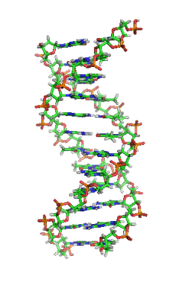
Name________________________
DNA
DNA is often called the _____________________________________
In simple terms, DNA contains the _____________ for making _____________________ within the cell.
Watson & Crick’s Model
- In 1953, _____________________________ built the first model of DNA with tin and wire

Why do we study DNA?
We study DNA for many reasons, e.g.,
- its central __________________________________ on Earth

- medical benefits such as cures for _____________

- _____________________________________
Chromosomes and DNA
Our genes are on our chromosomes.
Draw Picture: Cells and Chromosomes

Chromosomes are made up of a chemical called
________

The Shape of the Molecule
- DNA is a very long ________________
- The basic shape is like a __________________________________
- This is called a _____________ _____________________________

The Double Helix Molecule
The DNA double helix has __________ strands _________________ together.
One Strand of DNA=__________________
The backbone of the molecule is alternating __________________ and ____________________ sugar
The teeth are nitrogenous ______________
Nucleotides
One deoxyribose together with its phosphate and base make a nucleotide.

- One Strand of DNA
- One strand of DNA is a polymer of _______________
- One strand of DNA has many _______________ of nucleotides.
Four nitrogenous bases
________________________ C
________________________ T
________________________ A
________________________ G
Two Kinds of Bases in DNA
_____________________are single ring bases.
____________________ are double ring bases.

Thymine and Cytosine are___________________________
Thymine and cytosine each have one ring of carbon and nitrogen atoms.
Adenine and Guanine are ___________________________
Adenine and guanine each have two rings of carbon and nitrogen atoms.
Two Stranded DNA
Remember, DNA has two strands that fit together something like a _______________
The teeth are the nitrogenous bases but why do they stick together?
Answer = ____________________________________
The bases attract each other because of hydrogen bonds.
Hydrogen Bonds
When making hydrogen bonds,________________ always pairs up with ________________
________________ always pairs up with __________________
Chargraff’s Rule:
- Adenine and Thymine always join together _________________
- Cytosine and Guanine always join together __________________
DNA by the Numbers
- Each cell has about ________________ of DNA.
- The average human has __________________ cells.
- The average human has enough DNA to go from the earth to the sun more than _____________times.
- DNA has a diameter of only 0.000000002 m.

Remember DNA Replication occurs during the S-phase of interphase in Mitosis

REPLICATE THE FOLLOWING DNA STRAND OF BASES USING CHARGRAFF’S RULE:

ATGGCTATTAACGGA
_____________________________

