Cell Biology Unit Study Guide

1. A student could tell the difference between onion skin cells and cheek cells because the onion skin cells have a
2. What is the difference between a prokaryotic and a eukaryotic cell?

3. Why does a virus require a host cell?

4. What type of organisms are prokaryotes?

5. The function of a cell membrane is to

6. In the final phase of completion, proteins are modified by special enzymes in what organelle?

7. In which organelle would water and dissolved materials be stored?

8. Describe the structure and function of the following organelles: endoplasmic reticulum, ribosomes, Golgi apparatus, mitochondrion

9. Osmosis is defined as the movement of

10. The structure and function of membrane proteins are described as

11. The cellular structure that is involved in producing ATP during aerobic respiration is the

12. The membrane-bound organelles which convert solar energy to chemical energy are?

13. What is the function of the nucleus?

14. Which structure makes proteins using coded instructions that come from the nucleus?

15. The main function of the cell wall is to

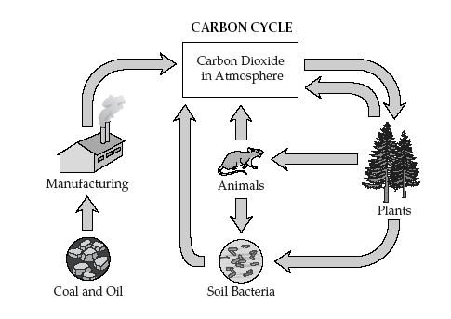

16. During photosynthesis, trees convert carbon dioxide and other materials to

17. The source of energy for photosynthesis is

18. Chloroplasts and mitochondria are organelles that are necessary for cells and organisms to function. Which type of organisms would have chloroplasts?

19. 6 C0₂ + 12 H₂0 ----------Light ------> C₆H₁₂O₆+ 6 H₂0 + 6 O₂
Chloroplasts
This formula is for which cellular process?

20. The products of cellular respiration are

21. Which organelle is responsible for cellular respiration?

22. Which organism(s) would perform photosynthesis?

23. A cellular process in which one molecule of glucose is broken down via a number of steps to produce a total of 38 ATPs is called

24. is an anaerobic breakdown of carbohydrates to produce a small amount of ATP.

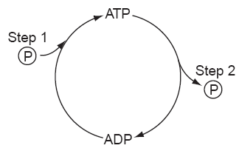
25. The diagram represents part of the process of cellular respiration. Energy is released and made available for metabolic activities at which step(s)?

26. Which organelles help provide cells with energy?

27. Which organism(s) would perform cellular respiration?

28. The reactants in photosynthesis are

29. The type of sugar produced by photosynthesis is

30. Which molecule in plant cells first captures the radiant energy from sunlight?

31. A cell from heart muscle would probably have an unusually high proportion of which organelle?

32. Plants take in energy by absorbing

33. Most cell membranes are mainly composed of

34. In a cell, which structure is the site of protein synthesis?

35. Which structures are found in every living cell?

36. Factors that increase the rate of diffusion of molecules across a semi-permeable membrane are _______.

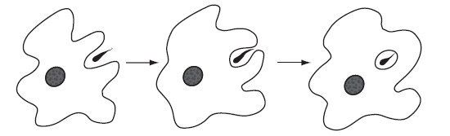

37. The series of diagrams represents a process carried out by a cell. This process is known as

38. The cell membrane of the red blood cell will allow water, oxygen, carbon dioxide, and glucose to pass through. Because other substances are blocked from entering, this membrane is called

39. Which organelle converts the chemical energy stored in food into compounds that are more convenient for the cell to use?

40. Unlike the cell membrane, the cell wall is

41. Diffusion is the movement of molecules from

42. Diffusion occurs because

43. Which means of particle transport requires input of energy from the cell?

44. Two organelles that are common to plant cells but not to animal cells are

45. Which parts do prokaryotic cells, eukaryotic cells, and viruses all share?

46. A wet mount of unstained elodea (a green aquatic plant) is observed using high power (400x) of a compound light microscope. Which structures would most likely be observed?

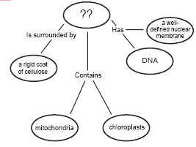

47. What best completes this concept map?

48. Prokaryotes lack

